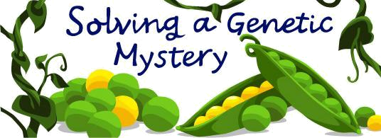

CO2
Infer the flow of information in living systems through simple genetic experiments

9 | Flow of information in living systems: Mendelian model, Monohybrid and Law of Segregation, Law of dominance, Test cross
10 | Dihybrid cross, Dihybrid test cross, Law of independent assortment
11 | Morgan concept on location of factors, recombination, crossing over
12 | Recombination frequency, Map distance
13 | Pedigree analysis
Class 9
Flow of information in living systems: Mendelian model, Monohybrid and Law of Segregation, Law of dominance, Test cross
THE LOGIC OF MENDEL

All of us have some characters similar to our parents or grand parents. Many of us like to look like or behave like our parents. Our grandparents, most of them are farmers, selected the best seeds for their next season. All of them knew that the best seeds have the best characters. Characters are passed to next generation through seeds. Seeds comes from flowers. Bees visit flowers for honey. Flowers contain honey fine powders.

Here we are trying to understand logically, how a normal man like Mendel who had lowest grades in Biology could do such meticulously planned experiments? Above all he had failed for a teaching certificate in natural sciences! On the other hand Mendel studied physics, mathematics and chemistry along with important aspects of biology. This mathematical back ground enabled Mendel to plan his experiments, draw out a theory and experimentally evaluate it.

We are logically going to understand what brought Mendel to understand the concept. Remember to consider the context that are looking at this from Mendel's perspective. He knew nothing about meiosis, never considered chromosomes or whether they had anything to do with what he was investigating. The word "gene" was invented after his death. All he did was breed peas, and do some high quality thinking. All this done between 1856 and 1863!

It is also interesting to see what is Mendel’s previous knowledge? Sometimes early in his life he worked as a gardener and done the beekeeping. He also studied practical and theoretical philosophy and physics at the University of Olomouc, Czech republic. He happened to see the research of hereditary traits of plants and animals, in the department of natural history and agriculture. He also worked as a substitute high school teacher. He failed in getting a certificate for teacher and send to University of Vienna for further study on a sponsorship. He returned and again worked as physics teacher, but failed on the oral part of examination. Finally he was taken the superior priest of the monastery.

Mendel’s work can be divided into the following steps: (A) Preparation for experiments (B) Choice of experimental material (C) Planning and execution of experiment (D) Interpretation of experimental results and (E) Further testing of his observations.

A. Preparation for Experiments

How do to an experiment? The laboratory should be accessible! That is Mendel approached the head of the department of Natural history and agriculture where he was working as a priest for permission to use the 2 hectar experimental garden intended to study differences in plants. His colleges conducted studies on the heredity of sheep. Why he wanted the entire full 2 hectares rather a few cents or pots? If we need to have a reliable results, the sample size should be very high! Therefore how much land you need to cultivate around 20,000 pea plants? Ask a farmer!

B. Choice of the experimental material

First he decided to work on plants? Do you know why? Plants attain reproductive age very soon compared to many animals, the number of plantlets from a plant will be very high, Many plants

can be grown together and above all plants reproduce through seeds which we will get from flowers!. Now the question is which plant? Shall we take a mango tree? Here comes the advantage of critical observation. The feasibility. It is Pea plants, because very easy to cultivate, flowers are big (think why?), number of plantlets produced from one flower will be more and above all its generation time is less. But the most important thing? What is the aim of the experiment? To study variation in plants? So we need to study variation. Examples of variation? Flower color, seed color, seed size and shape, flower position etc. So the experimental plant should have easily recognizable variations. From the Mendel’s observations it is the Pea.

C. Planning and execution of the experiment

Selection of variations: He selected the following characters: 1. Seed shape [Spherical Vs Wrinkled]; 2. Seed color [Yellow Vs Green], 3. Flower color [Purple Vs white], 4. Pod shape [inflated vs constricted], 5. Pod color [green pod vs yellow], 6. Flower position [Axial vs Terminal] and 7. Plant size [Tall Vs Dwarf] (The first logic of Mendel: Easy recognizable separate characters for observation -that had well-defined, contrasting alternative traits)

Why he selected seven characters? How did he do? He selected seven variations simultaneously in each experiment or separate experiments for separate variations? What you feel? He conducted different experiments for different characters first of all to see that whether he is getting the same kind of results in each case, secondly it is easy to follow the inheritance of one character at a time rather all together. That was the second logic of Mendel.

This third logic of Mendel from the knowledge he may got from his practical knowledge on agriculture and theoretical knowledge he got from mathematics. Does Mendel randomly selected seeds? We should know which characters seeds are inherited? We are studying variation, should we select seeds which show consistent inheritance or variable inheritance? The choice should be of consistent inheritance. He knew that it is possible to raise plants with consistent inheritance by crossing sibling plants. That is Mendel used well defined seeds as the starting material in all his experiments involving thousands of plants. So if we want to test the fuel efficiency of 10 different bikes, we should use the same experimental conditions in all the cases against one variability. This is the spectacular logic he applied and the basis of Mendel’s success.

The fourth logic is experimental. How to do controlled breeding? We want to cross a tall plant with a dwarf plant. So we need to ensure that only the pollen grain of the tall plant is falling on the stigma of the dwarf plant and vice versa. How to do this? Simply bag the flower bud, cut the stamens of the experimental flower, take the pollen grain from the other flower using a brush, “paint” on the stigma of the initial flower, bag it again to avoid unwanted entry of other pollen grain. (See the animation). Get the seeds from the flower and observe for the variation intended to study!

Here is the fifth logic. He just crossed only once. All other experiments involved self-pollination. i.e., he allowed mixing of two different characters only once. Why not twice or thrice? As simple as this, first let us start from simple things! So do the cross only once, avoid complexity and evaluate the results.

Now comes the sixth and final logic. Looking behind a character how many generations we should follow after crossing? Again comes the simplicity and reproducibility. Just followed the first generation after crossing.

So in short he started with the same experimental plan is as follows:

Tall plants Dwarf plants

True breeding Tall plant True breeding dwarf plant

First filial generation (F1) Cross product (Self pollinate)

Second filial generation (F2) Raise the plants look for variation how it was passed

Do the counting for the variations, tabulate

Figure 1

The seven variations observed in Pea plant that Mendel followed: Are they easily recognizable?

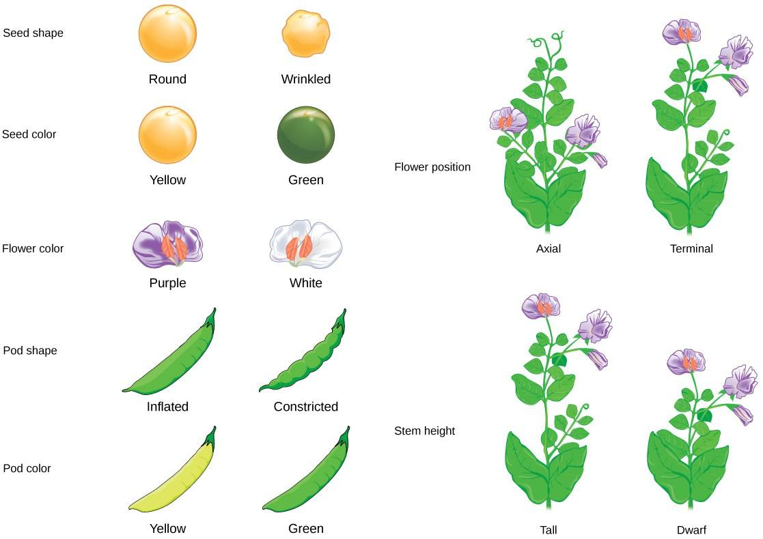

Figure 2 Flower structure of Pea: Observe the reproductive parts of the flower.

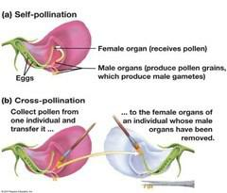

Photo of Mendel’s Experimental Model i.e. Green Peas:

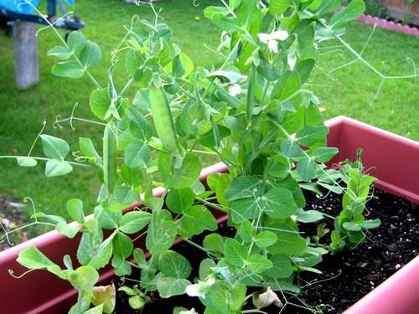

Mendel’s controlled experiments and elucidation of the results

MONOHYBRID CROSS AND SEGREGATION

THE RESEATRCH METHOD OF MENDEL

All of us now that pollen grains of one flower falls on the stigma of another flower or same flower. From the stigma the male nucleus of the pollen grain reaches the ovary and fertilizes an egg to produce a zygote. In plants fertilized zygote produces the seed and the ovary produces the fruit. The problem faced by Mendel is controlled pollination. Suppose he want to cross a tall plant with a dwarf plant. In this case the pollen grains of dwarf plant only should fall on the stigma of the dwarf plant or vice versa. How to achieve this? (Solve this problem with the help of the following figure and the animation provided)

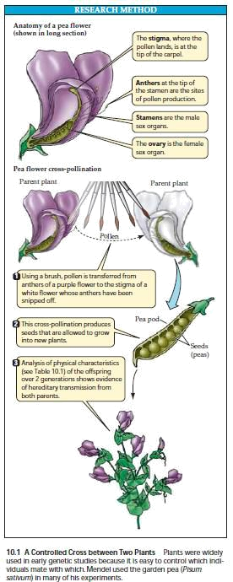

EXPERIMENTS RESULTS OF MENDEL

We have seen what Mendel’s logics were and how he executed the experiments. After his experiments the results were carefully tabulated by him. Analyze the following table showing the tabulation of Mendel

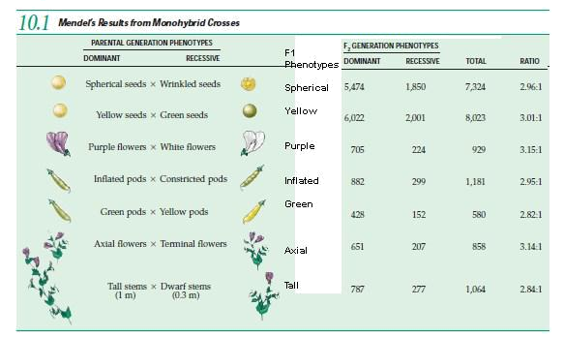

What you find here?

- Only one character appeared in the F1 generation

- Both characters were appeared in the F2 generation, but not in equal percentage

- A character which disappeared in the F1, reappeared in F2

- The results are consistent in all the seven characters

- There is no blending of characters

The analysis of the results clearly indicate the following

The character which appeared in the F1 is having the higher percentage in F2 i.e. almost three times to that of the disappeared character in F1. What you will conclude from these results? The character which is appeared in the F1 is also dominating in F2 also. This is the Dominant character. The other or alternative character which is disappearing in the F1 generation is also less in number compared to dominant character. This is Recessive character. (Law of Dominance).

Many of us, including Mendel, expected a blended phenotype in F1. But it didn’t happen. Why? Can’t the characters blend? The experimental results in all the seven characters studied by Mendel didn’t showed any blending (i.e. when we cross a Tall and Dwarf plant we can expect a plant intermediate between tall and dwarf; but it didn’t happen). This further means that some “units” which functions as discrete particles are responsible for characters. Since the character which disappeared in the F1 reappeared in F2 it is logic to conclude that these units occur as pairs. It means that two discrete units are responsible for the “Tall” character. Otherwise any given individual can be homozygous (Dominant/Dominant or Recessive/Recessive) or heterozygous (Dominant/Recessive). We can express the alternate forms of characters (dominant or recessive) as alleles. Also we know at present that character means a gene. So alleles are alternate forms (in fact variables) of a gene.

The factors can be represented as any letter forms (similar to polynomials). For example a tall plant can have TT or Tt. A dwarf plant can be represented as tt. This binomial expression is the genotype. In conclusion the “units” (or factors) are discrete, they never blend and are responsible for passing character from one generation to next ie inheritance.

Why two units of inheritance? Not three or four? We have father and mother. i.e. we have characters both from our father and mother. A character is represented by two units. One unit inherited from father and one from mother. So the gamete contains one unit. This is the core idea of Mendel’s inheritance. At present the “units” proposed by Mendel is known as gene.

The following figures illustrates a typical Mendelian cross.
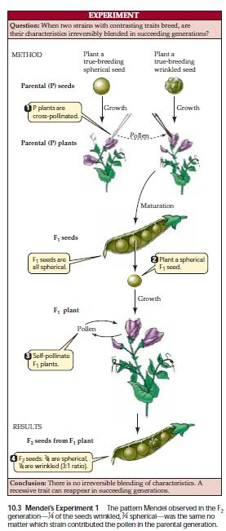

Now study the following cross which can be represented in the form of a Punnett square (A simple grid representing all possible gametes and combinations. Given the credit to Reginald Crundall Punnett, a British geneticist)
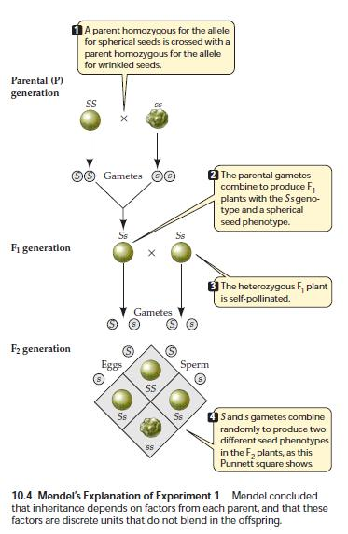

In conclusion the units of inheritance are never blended, but segregated independently during reproduction (Law of segregation). This is the second core idea of Mendel’s theory.

Another illustration is here for you regarding the cross between a Tall plant and a Dwarf plant.

This illustration represents Mendel’s core ideas.

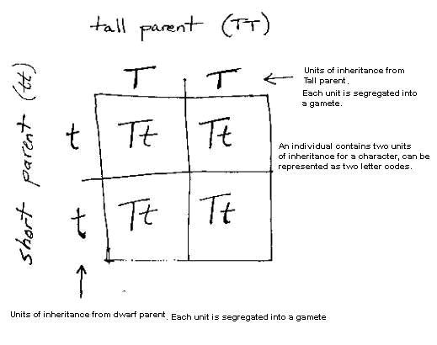

Terminologies, Back cross and Test Cross, Dihybrid cross
Verification of Mendel’s hypothesis:

He did verification experiments for his hypothesis, as illustrated below.

Similarly the following figure illustrates a dihyrbid test cross

11

Mendel has modelled one experiment, he executed and finally he tested it. This type of cross is knows a test cross (Crossing the unknown genotype with the recessive parent). It can predict the genotype to be tested based on the phenotypic ratio of the cross output.

Class 10
Dihybrid cross, Dihybrid test cross, Law of independent assortment

Probability laws govern Mendelian inheritance: The Study of dihybrid cross

Initially Mendel did all his experiments by analyzing only one character at a time – monohybrid cross. Based on his results, he has tested his hypothesis of dominance and segregation. After this he wanted to study the inheritance of two characters at a time – the dihybrid cross

The experiment is planned in such a way to analyze the following:

Whether the alleles maintain the association they had in the parental generation: For this he crossed pure breeding spherical seed and yellow seed color pea plant with a wrinkled seed green seed color pea plant. If the alleles maintain the association, he is expecting only the parental types in the F2 generations (Why not F1 generation?)

If the alleles maintain the association, the F1 gametes will be SY and sy. As a result the probability of Spherical and yellow seed peas: wrinkled and green seed peas will be 3:1 (i.e.only two phenotypes). If they segregate independently he was expecting four different phenotypes.

The experiment and the results are illustrated as below

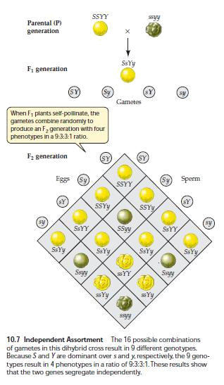

He didn’t get a 3:1 ratio in F2 generation. New types were obtained in F2. It means that the alleles didn’t maintain the same association as seen in the parental types, rather they assorted independently (Law of Independent Assortment).

Mendel and his Mathematics predictions.

You have a 1 rupee coin and 5 rupee coin. probability of getting a tail in both cases? independent?)

You are going to toss it together. What is the (Are the two events linked to each other or

Probability of getting a 1 rupee tail = ½. Probability of getting a 5 rupee tail = ½

13

Hence the probability of getting both tail = ½ X ½ = ¼ i.e. 25%.

In a homozygote (SS), the probability of producing a S gamete is 1

In a heterozygoute (Ss), the probability of producing a S gamete is ½ and s gamete is also ½ Now consider the F2 generation. The probable gametes here are S and s.

Hence the probability of getting SS is ½ X ½ = ¼ i.e. 25% are homozygous dominant

The probability of getting ss is ½ X ½ = ¼ i.e. 15% are homozygous recessive

Adding probabilities: What is the probability of getting Ss and sS?

Probability of Ss (S from sperm and s from egg) = ½ X ½ = ¼ Probability of sS (s from sperm and S from egg) = ½ X ½ = ¼

Both Ss and sS are heterozygotes and will have the same phenotype. Hence added probability is ¼ + ¼ = ½ ie 50% will be heterozygotes.

Now can we calculate the probabilities in dihybrid cross?

In F2 generation, the probabilities are illustrated below

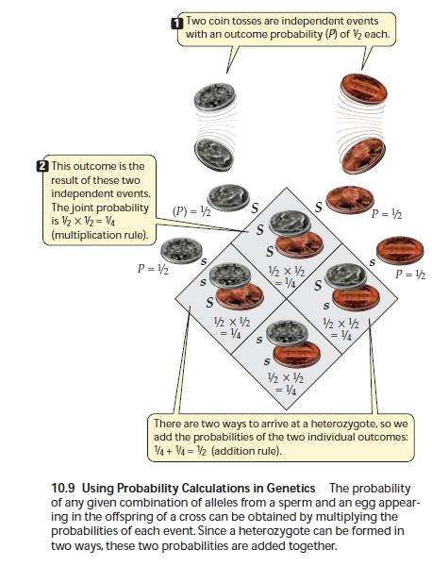

Now what is the probability of getting an SS homozygote ? i.e. ¼

The probability of getting heterozygote (i.e. Ss or sS) is ¼ + ¼ = ½

The added probability (i.e. spherical seed ) = ¾

Now calculate the probability of yellow seed using the above reasoning? It will be ¾

Hence what is the added probability of getting a spherical seed and yellow seed = ¾ X ¾ = 9/16 (Since both events are independent i.e. independent assortment)

What will be the probability of getting a yellow and wrinkled seed?

Probability of yellow seed = ¾

Probability of wrinkled seed = ¼

Hence the added probability = ¾ X ¼ = 3/16

Using the same logic it is easy to calculate the probability of wrinkled yellow seed is 3/16 and wrinkled green seed is 1/16.

Mendel did all these statistical problems. Because of his mathematical knowledge, he could easily predict, the ratio obtained in F2 generation of monohybrid and dihybrid crosses are simply a statistical event and the factors are independent of each other.

You should understand both; i.e. doing a genetic problem by using probability and by using a Punnett square.
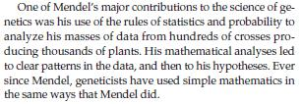

It is also possible to test the dihybrid genotypes as illustrated below. Similar to monohybrid test cross, it is possible to predict the genotype of a phenotype by crossing with a true recessive parent. The prediction is based on the characteristic phenotypic ratio we will get in this cross.

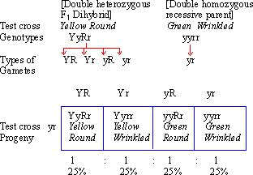

Chromosomes and cell Division, Chromosomal Theory
Mendel experiments: Did he predict chromosomes?

(Meiosis accounts for segregation)

The segregation of Mendelian factors is because of meiosis

Mendel proposed mechanisms of heredity. Mendel had no knowledge of chromosomes or meiosis. But he speculated that cells contained some type of factor that carried traits from one generation to the next. The scientific importance of Mendel’s work remained unrecognized for several years. Most probably Mendel believed that for each character there is a factor. Currently we know that this factor is a gene (or an allele) that is located on a chromosome. They show characteristic segregation and independent assortment are due to meiosis (Illustrated below).

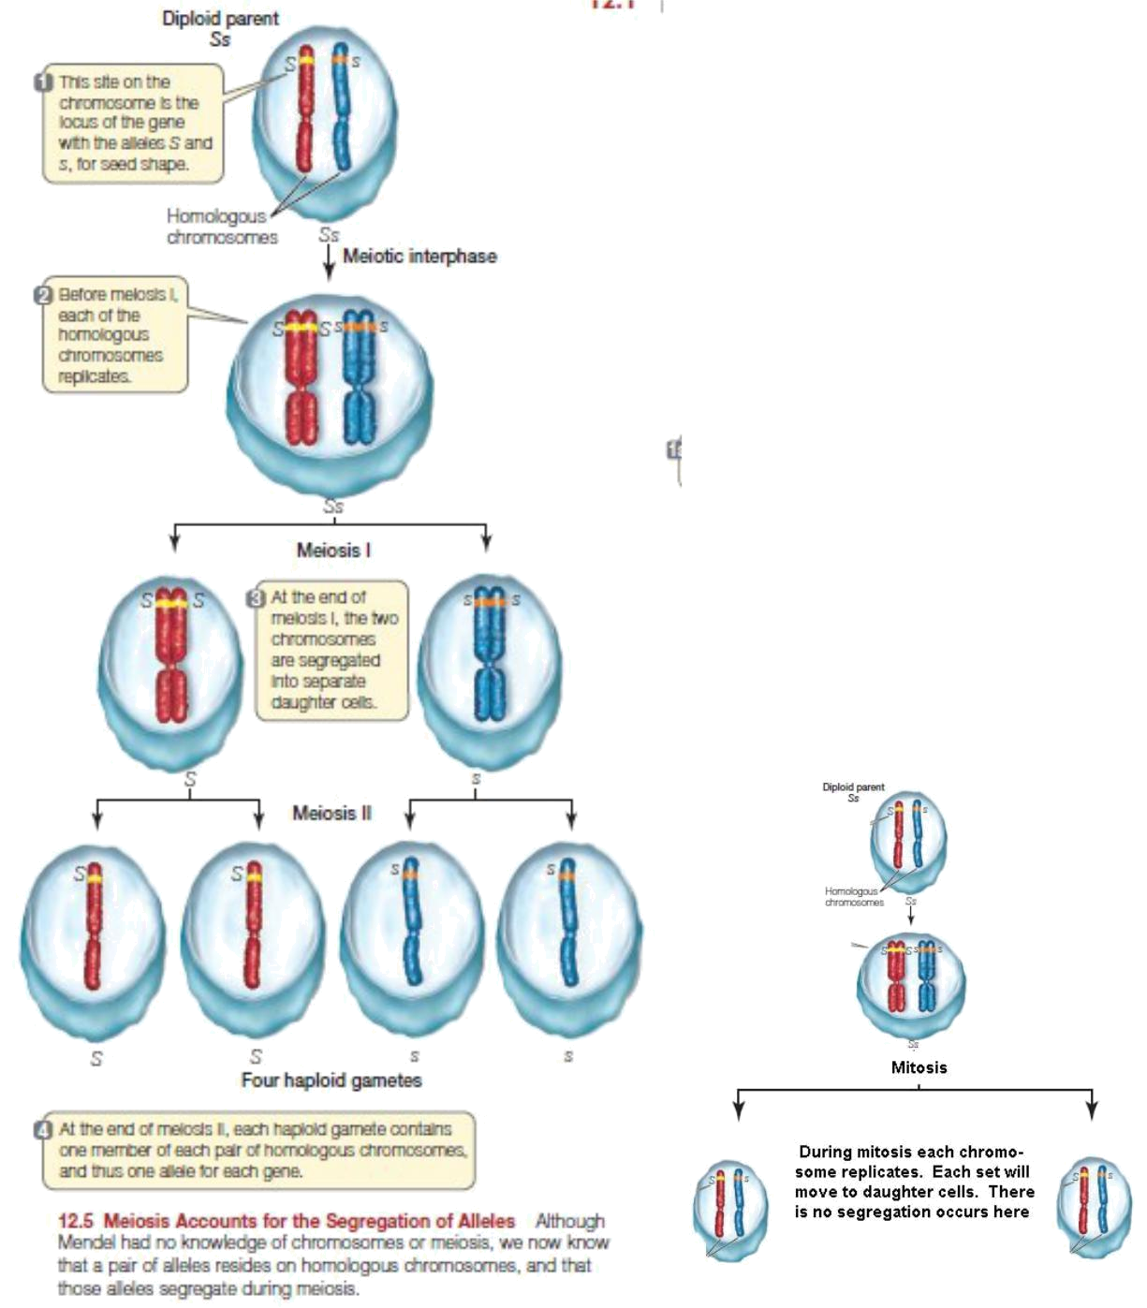

So if we have a cell with a genotype Ss it should produce two types gametes, i.e. one type with S and another type with s. Mendel said the two alleles will segregate. Our current knowledge is that meiosis accounts for segregation. This is exactly matches what Mendel speculated from his results. He also proved that each factor segregates when traits passed from one generation to another generation.

What happens in mitosis? A cell with genotype Ss just produces two daughter cells with the same genotype as illustrated above and there is no segregation.

Now you will see how alleles assort independently during meiosis when we consider a dihybrid cross

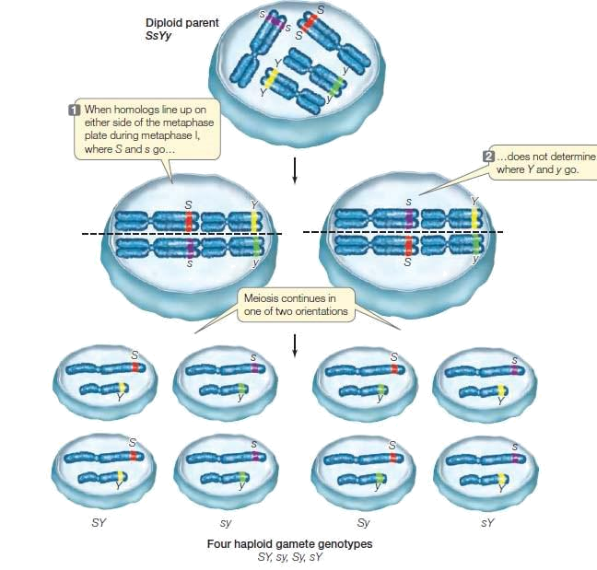

Mendelian principles doesn’t applies to all cases of inheritance.

Whether all the inheritance follows Mendelian pattern? Human have several traits like hair pattern, skin color, tasting ability, shape of ear and so on. How many chromosomes we have? 23 pairs. So if Mendel’s rules we apply, we should have only 23 chromosomes. Hence it becomes clear that a chromosome can contain more than one factor. Now we have to think that who is the luckiest Man? It is Mendel. He selected seven characters. Each character was regulated by a gene and they were located in seven different chromosomes. Now we know that Pea plant has seven chromosomes. Suppose if the traits selected by Mendel resides on the same chromosome, he will not get a 9:3:3:1 ratio as expected.

In short if we get a ratio of 9:3:3:1, we can assume that the genes we selected are located on different chromosome. If we are not getting this ratio, then genes may be on same chromosome. The genes on the same chromosome means that they are linked.

The seven chromosomes of Pisum sativum. Luckily the seven genes for the selected traits by Mendel was located on seven different chromosomes leading to his success in modelling his hypothesis and successful testing. If it was not, Mendel might have failed in his efforts. Hence many people believes that Mendel was the luckiest person.

Class 11
Morgan concept on location of factors, recombination, crossing over
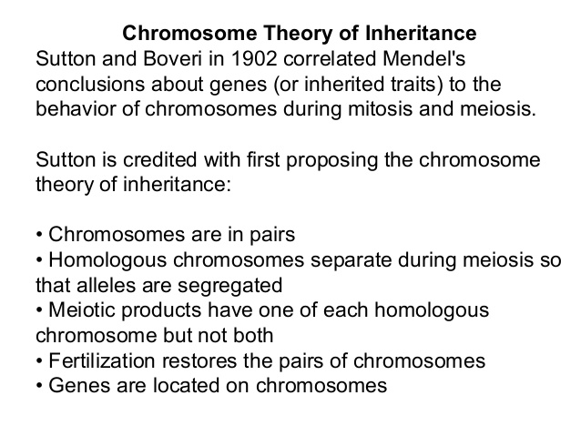
Two types of cell Division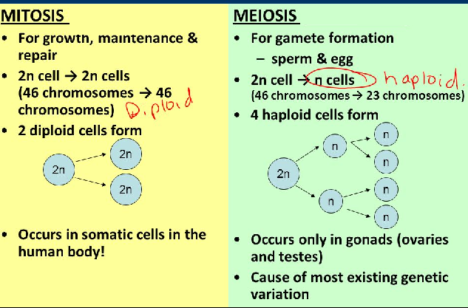

Morgan’s experiments
Morgan and his Drosophila: Mendel’s hypothesis is rejected in Morgan’s experiments
[Chromosomal theory, Connecting Mendel to Morgan, Linkage and crossing over]

Thomas Hunt Morgan and his students of Columbia University did pioneering works to explain heredity from the beginning of 1909. He explored the Mendel theories in Drosophila melanogaster, the fruit fly as the experimental organism. He selected fruit fly because of its small size, easy to grow and breed and its short generation time.
Thomas H. Morgan correctly perceived that the success of genetic investigators depended critically upon the choice of the organism to be investigated. Much of the work in the early years had centred upon agricultural plants and animals: we knew how to grow successive generations of them, and the information had direct practical bearing. Morgan abandoned agricultural utility in favor of experimental utility-plants just took too long between generations, and they took up too much space. Morgan wanted an organism with which one could carry out many crosses, with many progeny, easily and quickly. With this in mind, he began to investigate the genetics of Drosophila. No genetic varieties were available in Drosophila, so Morgan set out to find them. He obtained his first mutant in 1910, from normal red eyes to white. At last he could set out to examine Mendelian segregation.

MORGAN’S FRUIT FLY CROSSES
First, Morgan crossed the white-eyed male he had found to a normal female, and he looked to see which trait was dominant in the F1 generation: all the progeny had red eyes. Now, would the white-eye trait reappear, segregating in the F2 progeny as Mendel had predicted? In the F2, there were 3470 red-eyed flies and 782 white-eyed flies, roughly a 3:1 ratio. Allowing for some deficiency in recessives, this was not unlike what Mendel’s theory predicted. But in this first experiment, there was a result that was not predicted by Mendel’s theory: all the white-eyed flies were male!
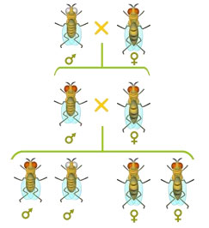
At this point, Morgan had never seen a white-eyed fly that was female. Morgan preferred a straightforward test: if any of the F2 females carried the white-eye trait but did not show it, then it should be revealed by a test cross to the recessive parent. It was. Crossing red-eyed F2 females back to the original white-eyed male, he obtained 129 red-eyed females, 132 red-eyed males, and 88 white-eyed females, 86 white-eyed males.
Again, this was a rather poor fit to the expected 1:1:1:1 ratio due to a deficiency in recessives. The important thing, however, was that there were fully 88 white-eyed female flies. Clearly, it was not impossible to be female and white-eyed. Why, then, were there no white-eyed females in the original cross?

X AND Y CHROMOSOMES
We know that in mammals and many other animals sex is determined by chromosomes i.e. XX will be female and XY will be male. Thus, sperm may contain either an X or a Y chromosome, while all the female gametes will contain a copy of the X chromosome. In forming a zygote, sperm that carry an X chromosome will produce an XX zygote (female), while sperm that carry a Y chromosome will produce an XY zygote (male). This simply model explained the 1:1 proportions of males to females usually observed, as well as the correspondence of sex with chromosome cytology.

SEX LINKAGE
This theory provided a really simple explanation of Morgan’s result, and he was quick to see it: what if the white-eye trait is resided on the X chromosome? Morgan had only to assume that the Y chromosome did not have this gene (it was later shown to carry almost no functional genes). Knowing from his previous crosses that white-eye is a recessive trait, the results he obtained could be seen to be a natural consequence of Mendelian segregation!
Thus, a typically Mendelian trait, white-eye, is associated with an unambiguously chromosomal trait, “sex.” This result provided the first firm experimental confirmation of the chromosomal theory of inheritance. This association of a visible trait that exhibited Mendelian segregation with the sex chromosome (sex linkage) was the first case in which a specific Mendelian gene could be said to reside on a specific chromosome. It firmly established the fusion of the Mendelian and chromosomal theories, marking the beginning of modern genetics.
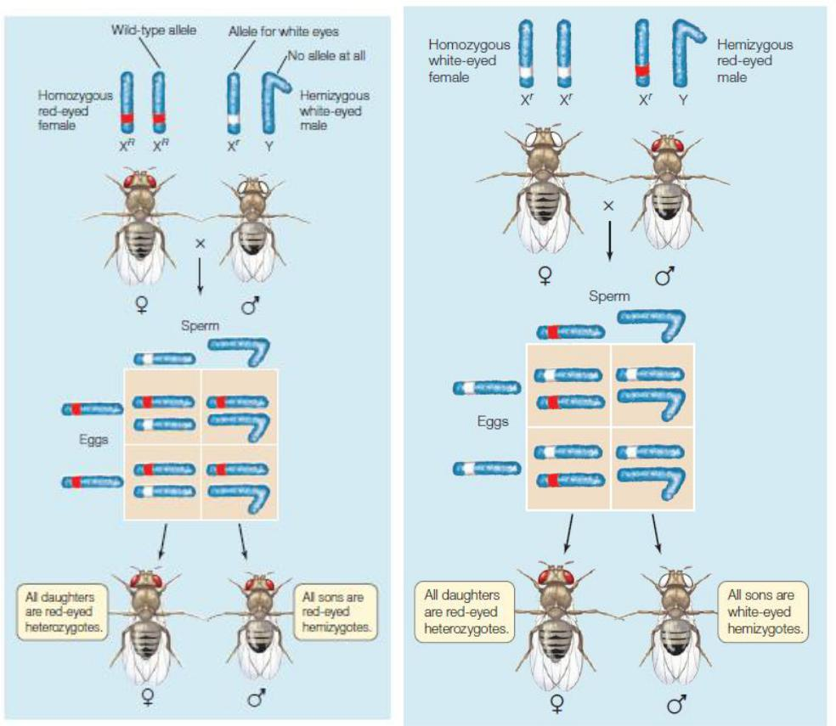

In the above cross, the normal allele is red, the recessive allele is white. Red is dominant over white. Whenever the white male is crossed with a true breeding red female the result is both male and female flies are red eyed. Whenever a red male is crossed with a true breeding white female all male offspring’s are whited eyed and female flies are red eyed. So the gene for the trait eye color in Drosophila resides on X linked chromosome. This inheritance is X linked recessive. We can show X linked inheritance in the pedigree chart illustrated below.
Did you note three things (1) in females, both X chromosomes should carry the recessive allele for the expression of white eye color. Hence this is an X linked recessive trait. (2) Males have only one X chromosome. Hence the trait will express even if the X chromosome contains the recessive allele (3) X linked recessive traits are more frequently occurs in males compared to females. The reason is that males have only one X chromosome. Hence the recessive allele will express.

Recombination of linked genes: crossing over

From the independent assortment of chromosomes revealed that the traits that do not match those of either parent for e.g.: the cross between a pea plant with yellow-round seeds that is heterozygous for both seed color and seed shape (a dihybrid YyRr) and a plant with green-wrinkled seeds homozygous for both recessive alleles (test cross) 1:1:1:1 half of the offspring are called parental types and another with new combinations of seed shape and color are called recombinant type with 50% frequency of recombination. The proof that the genes were located on chromosomes was provided by single small fly.
Thomas Hunt Morgan’s drosophila dihybrid experiments for the body color and wing size. Wild type flies have gray bodies and normal-sized wings. In addition to these flies, Morgan had managed to obtain, through breeding, doubly mutant flies black body and wings much smaller than normal, called vestigial wings. Mutant alleles are recessive to the wild – type alleles. Morgan wanted to know whether the genes for body color and wing size were genetically linked, and if so, how this affected their inheritance. The alleles for body color are b_ (gray) and b (black), and those for wing size are vg_ (normal) and vg (vestigial). Morgan mated true-breeding P (parental) generation flies—wild-type flies with black, vestigial-winged flies—to produce heterozygous
F1 dihybrids (b_ b vg_ vg),all of which are wild-type in appearance. He then mated wild-type F1 dihybrid females with black, vestigial-winged males. This testcross will reveal the genotype of
the eggs made by the dihybrid female.
The resulting flies had a much higher proportion of the combinations of traits seen in the P generation flies (called parental phenotypes) than would be expected if the two genes assorted independently. Morgan thus concluded that body color and wing size are usually inherited together in specific (parental) combinations because the genes for these characters are near each other on the same chromosome. The Predicted ratios if genes are located on different chromosomes were 1:1:1:1. If the genes are located on the same chromosomes and parental alleles are always inherited together then the ratio is 1:1:0:0.
However, both of the combinations of traits not seen in the P generation (nonparental phenotypes) were also produced in Morgan’s experiments, suggesting that the body-color and wing-size alleles are not always linked genetically. To understand this conclusion, we need to further explore genetic recombination, the production of offspring with combinations of traits that differ from those found in either parent.
Since most offspring had a parental (P generation) phenotype, Morgan concluded that the genes for body color and wing size are genetically linked on the same chromosome. However, the production of a relatively small number of offspring with non parental phenotypes indicated that some mechanism occasionally breaks the linkage between specific alleles of genes on the same chromosome.

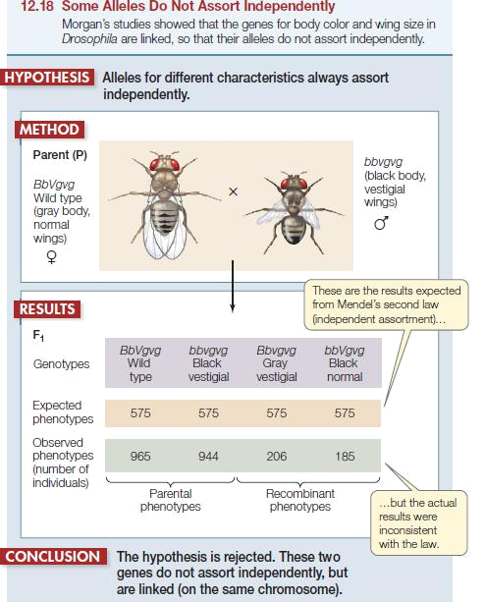

What Morgan expected is a 1:1:1:1 ratio (Recollect Mendel’s dihybrid test cross ratio)
Total individuals = 965+944+206+185 = 2300
Parental types = 965 + 944 = 1909
Non parental types or recombinant types = 391

Recombination frequency =( Recombinant types/Total individuals) X 100
= (391/2300) X 100 = 17% (We can also write recombination frequency as 0.17 assuming that maximum recombination is 1)
Now we have to see why the new phenotypes (non-parental phenotypes) occurs?

The new phenotypes appear because of exchange of genes between homologous chromosomes that occurs during meiosis (swapping). This event is known as crossing over. Look at the following illustration to understand the process.
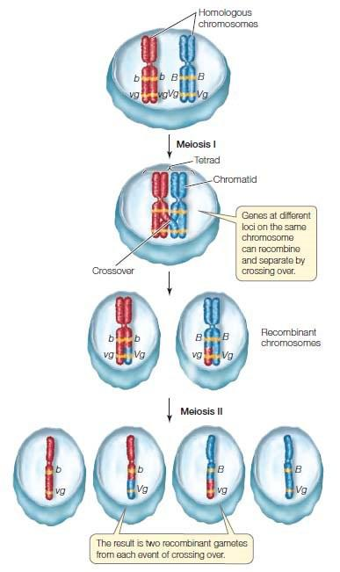
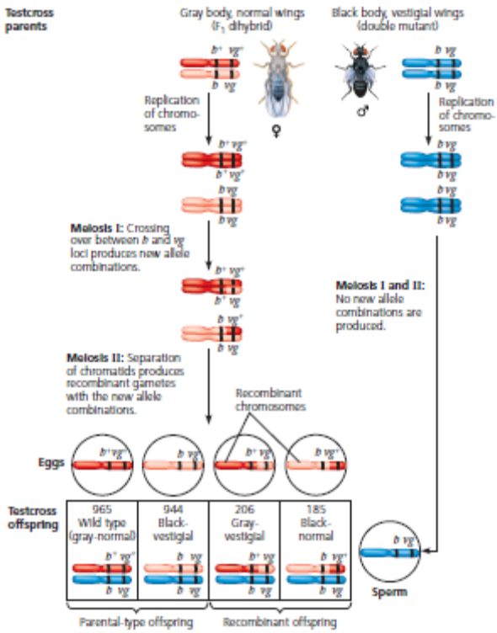

If we consider Morgan’s Drosophila testcross result offspring from the testcross for body color and wing size most of the offspring (>50%) had parental phenotypes and about 17% of offspring were recombinants. This suggested that the two genes were on the same chromosome.
With these results, Morgan proposed that some process must occasionally break the physical connection between specific alleles of genes on the same chromosome. And this process is called crossing over which accounts for the recombination of linked genes. When replicating the homologous chromosomes are paired during prophase of meiosis I, an exchange of end portions of two non-sister chromatids takes places leading to crossover.

Towards the genetic map
The probability of recombination between two loci increases with distance. Morgan’s found recombination frequencies of many genes through experiments and used these frequencies to construct a genetic map or mapping the genes. A genetic map tells the distance between two genes. The following illustration helps us to find how to do a genetic map. It is measured in terms of centimorgan or cM.

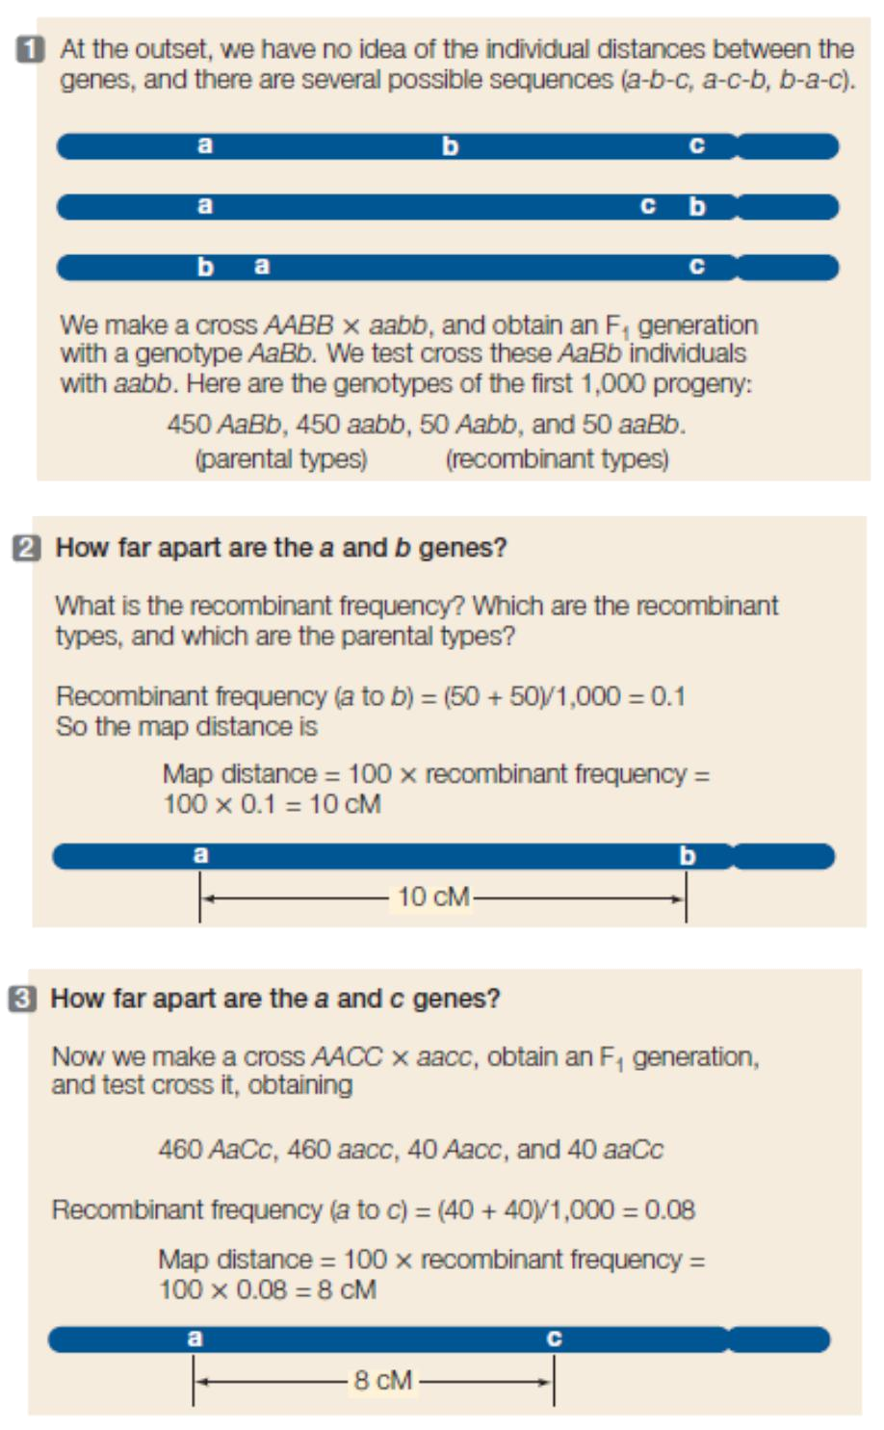

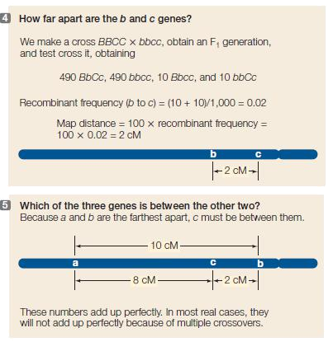
The recombination frequencies can be used for making genetic maps. Morgan’s group conducted several crosses in Drosophila. After finding out the frequency he was able to apply for construction of genetic map because the more the distance between two loci, the more will be the recombination. It means the distance between genes can be calculated based on this. The unit is cM (Centimorgan) or map units (1cM = 1 map unit). The following illustration shows an illustration of genetic mapping by Morgan.

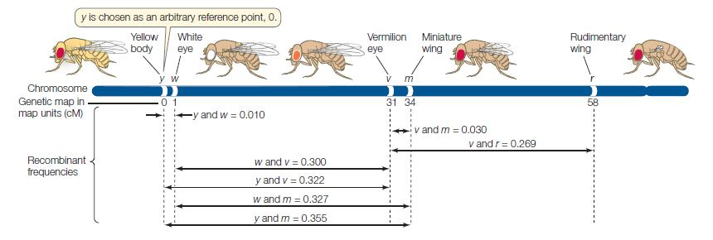

Flemming was a German military physician. He found cells contains the coloured genetic material, the chromosomes (Chrome = color; some = body). This is in fact the factor represented by Mendel. Even he discovered that chromosomes splits longitudinally during cell division (His illustration is given below). This is what happens during mitosis. We know, in meiosis the longitudinal splitting happens after crossing over.
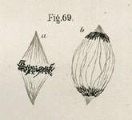

The chromosomal theory was not the work of a single scientist by Mendel or Morgan. Many people experimented over decades on it. Indeed, the first logic steps were initiated during 1860 by the mathematician Mendel and evolutionary biologist Charles Darwin. The probable mechanism of transmission from one generation to next was speculated by the discovery of chromosomes by Walther Flemming, a German biologist. Now to connect between chromosomes and heredity. This was done by Boveri, Sutton and Morgan during the dawn of 20th century. Thus the chromosomal theory came out which experimentally proved that chromosomes are responsible for transmission of trait from one generation to next.

In fact Mendel was a Physicist (and philosopher), Darwin was a naturalist, Morgan was a zoologist. Above all Flemming was a military physician!!

Class 13
INHERITANCE AND PEDIGREE

Life has evolved on earth gradually. Most of the life forms have two different sex, what we say is a male and a female or a + strain and a – strain. Why life preferred two genders? Male and Female? It would have been simple for the life if only one gender is existing and all of them will reproduce.
The advantage lies on the recombination event. During sexual reproduction, the chromosome number of the gametes are reduced into half through meiosis. We have seen that meiosis accounts for segregation and assortment. We have also seen the non-parental genotypes appeared in the F2 generation of dihybrid cross. It means sexual reproduction gives an opportunity for variation through meiotic recombination. Hence life systems are not static, they are dynamic. They are evolving. The most perfect life machine will always be preferred by the nature. Others will disappear, the survival of the fittest. It means the best character is inherited over the generations.
As we have seen with the Mendel and Morgan inheritance can be dominant or recessive
Now let us go through the different types of inheritance. Before discussing that we should see how to represent the inheritance in the form of a diagram. This is known as pedigree. The basic rules of pedigree chart is give below.
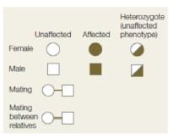

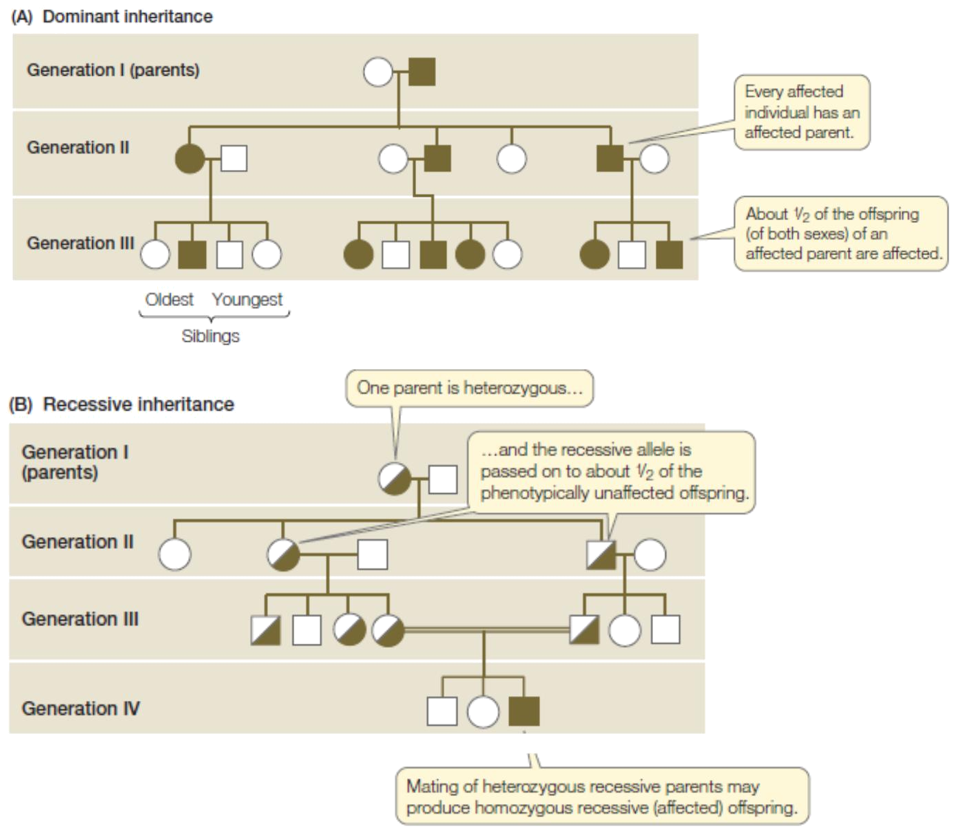

Now calculate the probability of the children getting affected in a cross . The male can be homozygous dominant or heterozygous. If he is homozygous dominant, the probability of an unaffected child is zero. This probability will be 50% if he is heterozygous in each child birth. Now see the probability in the case of a recessive inheritance . The probability of getting the child having the recessive character is zero, because we know that the expression of a recessive character occurs only in case of homozygous condition of the alleles. But the unaffected child may be a carrier of the allele, even though he or she is not expressing the trait. The above types of inheritance illustrated here appears on both sexes. Hence the factor or the gene is resided on the autosomes. So an autosomal inheritance can be autosomal dominant or autosomal recessive.

Autosomal dominant trait

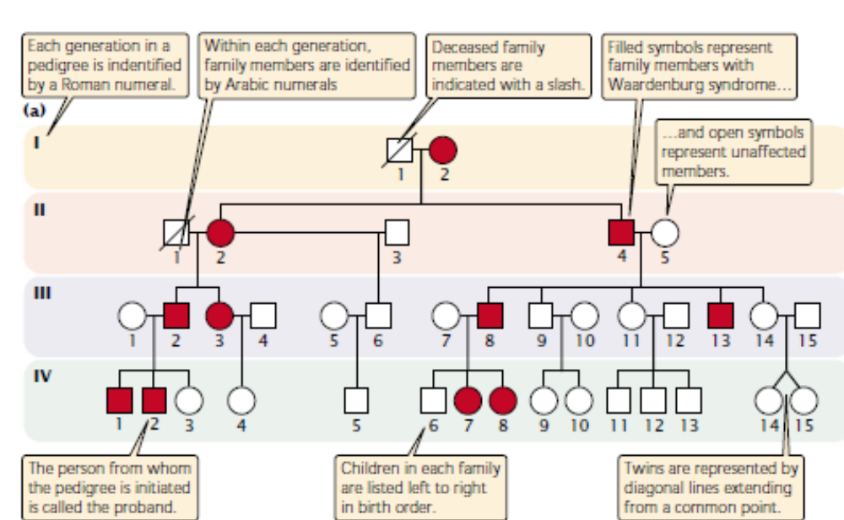

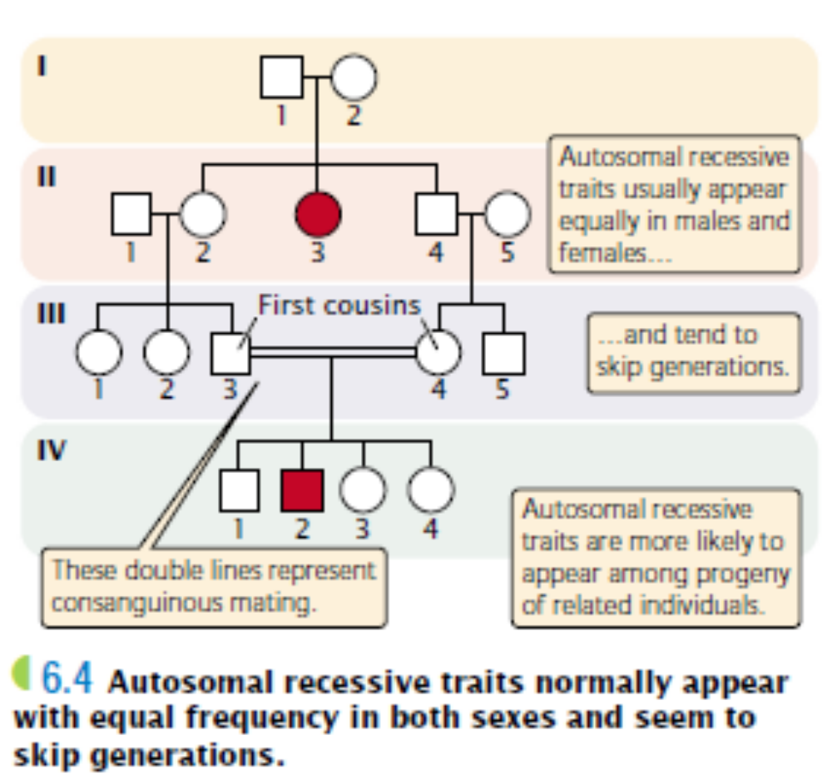
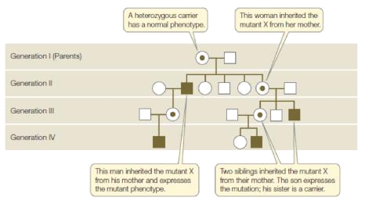
X Linked Recessive mode of inheritance

Did you noted three things (1) In females, both X chromosomes should carry the recessive allele for the expression of white eye color. Hence this is an X linked recessive trait. (2) Males have only one X chromosome. Hence the trait will express even if the X chromosome contains the recessive allele (3) X linked recessive traits are more frequently occurs in males compared to females. The reason is that males have only one X chromosome. Hence the recessive allele will express.
In some other cases, X linked characters may appear in dominant pattern also. Illustration is given
below

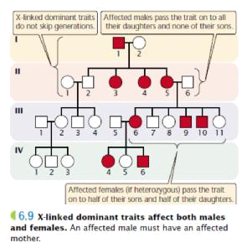

Some of the traits only appear in males because the gene for this trait are located on Y chromosome. They are passed by father to all of his sons, but not daughter. The illustration is given below
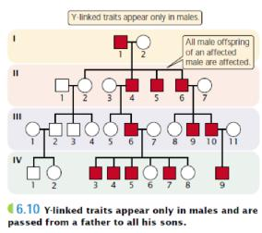
30
The following table explains the features of different patterns of inheritance
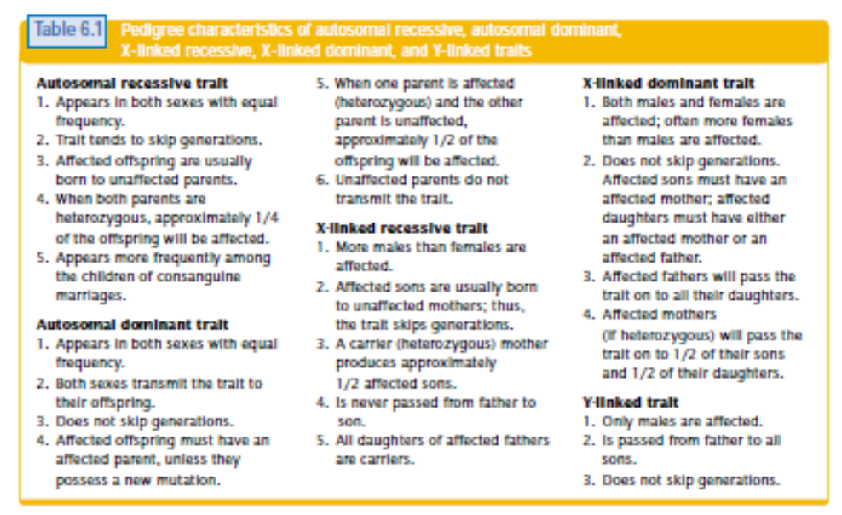

Diseases or traits can pass from one generation to another generation. Many of them follow typical Mendelian inheritance. The following table gives few examples

